The 2022 DDMS

Ski and Snowboard club

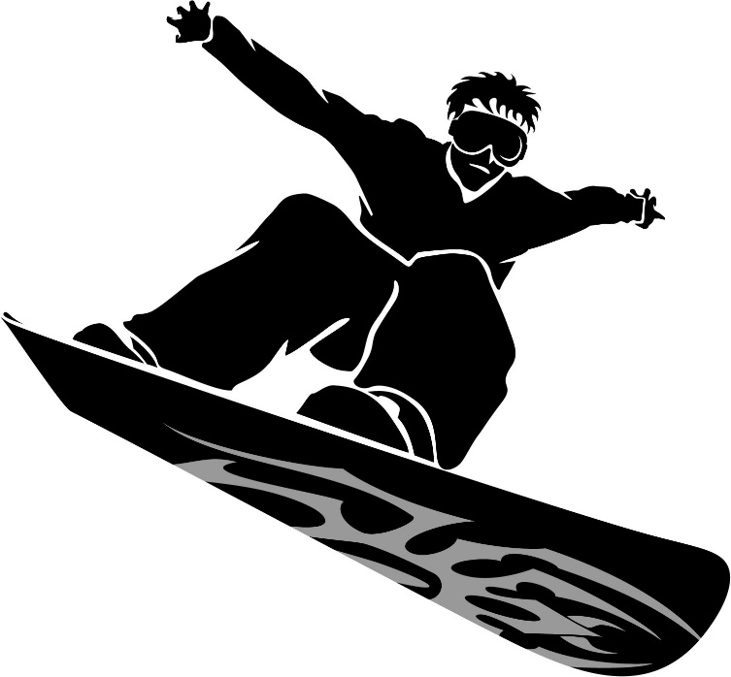

Advisors:

Mr. Curchoe

And

Mr. Kim

**\*\*\*The 3 things you need to sign up\*\*\***

1. Your emergency medical form

2. Sign up for your ski/snowboard package on Shawnee’s website

3. Transportation check for $40.00 (if taking the bus)

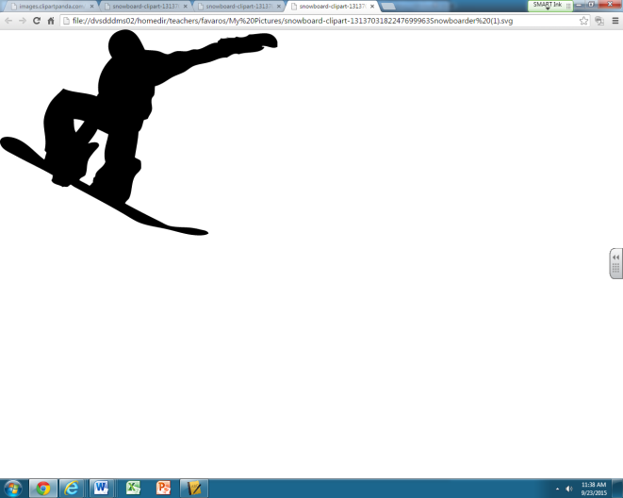**DDMS Ski and Snowboard Club  
 Permission to Participate and   
Emergency Medical Treatment Authorization Form**

I am the parent/guardian of ____________________________________________________, on whose behalf I am signing this permission form. I accept that there are inherent risks associated with the sports of skiing, snowboarding, and snowblading and agree that I am fully responsible for the cost of any injury my child may experience during club activities or while in transport to Shawnee Ski Resort. I hereby agree that my child has my permission to participate in DDMS Ski and Snowboard Club activities.

I further represent that to the best of my knowledge and belief, my child is physically and mentally able to participate in the sport of skiing, snowboarding or snowblading.

Parent/Guardian Signature:_____________________________________________ Date: _____________________

In the event my child, ___________________________________________________________, is injured during a DDMS Ski and Snowboard Club trip requiring consultation and/or treatment at a hospital by medical personnel and the undersigned cannot be contacted, the undersigned (Parent/Guardian)  
 of _________________________________________________________________ hereby authorize the advisor of the DDMS Ski and Snowboard Club to take those measures reasonably necessary to procure the medical examination and/or treatment, including but not limited to authority to authorize the said examination and/or treatment by hospital or medical personnel.

Parent/Guardian Signature:________________________________________________________________

Student’s Full Name:_________________________________________________________________________

Date:____________________________________________

Student’s Date of Birth:________________________________________________________

Parent’s/ Guardian’s Home Phone Number: _______________________________________________________

Parent’s/Guardian’s Cell Phone Number:___________________________________________________________

Parent’s/Guardian’s Cell Phone Number:___________________________________________________________

Parent’s/ Guardian’s Work/Emergency Number:___________________________________________________

**RETURN**

**Student Health Insurance and History Information**

Please note: The information contained on this form is confidential and may only be used or shared when using it to treat a student for an injury or illness.

**Personal Information**

Student’s Name: _________________________________________________________ Age: ________________ Grade:__________

Current Physical Address:_______________________________________________________________________________________

**Emergency Information**

Primary Emergency Contact Person’s Name:__________________________________________________________________

Relationship: ________________________________________________________________

Address:___________________________________________________________________________________________________________

Phone Number:___________________________________________________________________________________________________

Medical Insurance Carrier____________________________________________________________________________

Policy Number:________________________________________________________________________________________

Address:_____________________________________________________________________

Phone Number: ____________________________________________________________________________

Family Physician’s Name: __________________________________________________________________________________

Address______________________________________________________________ Phone Number: _________________________

Student’s Allergies: _____________________________________________________________________________________________

Student’s Health Conditions of which an emergency physician should be aware:_______________________________________________________________________________________________________________________________________________________________________________________________________________________________________________________________________________________________________________________________________________________

Student’s Prescription Medications: ____________________________________________________________________________________________________________________________________________________________________________________________________________________________________________________________________________________________________________________________________________________________________________________________________________________________________________________________________________________

**RETURN**

DDMS Ski & Snowboard Club

Dear Parent/Guardian(s):

Here is a list of reminders before we take our first trip:

* Sign up sooner than later! Spaces on the bus are limited and Shawnee’s discounted prices go up December 1st. **All sales close 12/15!**
* All personal ski/snowboard equipment needs to be brought to school by the parent the day of our trip. Students **WILL NOT** be allowed to take these items on the school bus in the morning.
* There will be a bus fee for each trip that we take. This price is based on 30 participants. **Students must bring a check written out to “DDMS-SAF” for $40.00 for the season’s transportation fee.**
* The bus will depart from DDMS at 3:00 pm and return to the school by 8:45 pm.
* Tentative Dates: 1/6, 1/13, 1/20, 1/27 (All dates are Thursdays)
* If a trip is cancelled there will be an announcement during school and a message will be sent on Connect Ed. Make-up dates will be announced as needed.
* Please dress appropriately for the trip. Snow pants, winter jacket, ski hat or helmet, and ski gloves are all necessary items.
* All students should either bring food or plan on eating at Shawnee. Food brought must be eaten on the bus as Shawnee is no longer allowing outside food. If you plan on eating at Shawnee, please bring $10-$15. Just a reminder there is a meal plan available to members through Shawnee which is a money saver.
* If any student or parent has any questions or concerns, please don’t hesitate to contact us. We will be happy to answer any questions.
* All Ski/Snowboard equipment is stored in Room E6 (Tech Ed room) the day of our trip.

Thanks,

Ryan Curchoe/Stephen Kim  
DDMS Ski & Snowboarding Coordinators  
Voicemail: X7119 (Curchoe)

|  |  |
| --- | --- |
| |  | | --- | | **How to sign up for your Shawnee Package**  **\*\*this must be done on Shawnee’s site\*\*** | |

|  |  |
| --- | --- |
| |  | | --- | | #1: Type in URL: <https://www.shawneemt.com/registration/> **#2: Read & agree to the Club Program Policies/Refund page** ****#3: Read & agree to our mountain's "****[Know Before You Go](https://www.shawneemt.com/mountain/covid-19-safety-guide)****" policies**** **#4: Read & agree to the Online Store Patron Responsibility page**  **#5: Welcome to the Group Login Page**  **Club Name:** 403mv **Member Password:** 2022member403 (case sensitive) **Tech Support: (570) 421-7231 x244 / club@shawneemt.com**  **#7: Select your package from the many options (note: lift only means you have your own mountain approved equipment. If not, you will need lift plus rental)**  **#8: Add on meal plan (highly recommended) and helmet (also recommended)** | |

**\*\*IMPORTANT\*\***

**\*\*A $40.00 check made out to “DDMS SAF” must be sent in and given to Mr. Curchoe or Mr. Kim with your forms! This is the transportation fee to pay for the bus down to Shawnee and back for all 4 trips. If you are carpooling down and NOT taking the bus you do not need to pay the transportation fee\*\***